**23.1. @OneToOne – Overview**

**One-to-One Mapping**:

An instructor can have an “instructor detail” entity. That’s a One-to-One relationship. We will model this in the database using two separate tables.

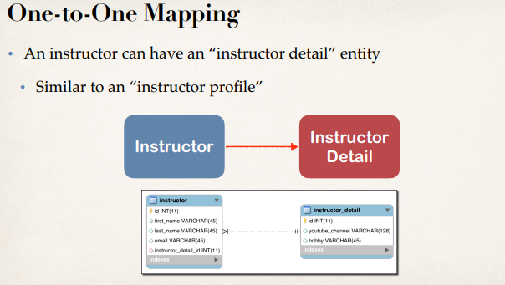

**Uni-Directional**:

The above example is Uni-Directional, so we will start with the instructor and then we will have a one-way relationship with the instructor_detail.

**Development process One-to-One**:

1. Prep Work - Define database tables
2. Create InstructorDetail class
3. Create Instructor class
4. Create Main App

**1) Create table in database**:

* instructor_detail
* instructor

File:

23.1. @OneToOne - Overview